Image Acquisition and Representation

Code:
import cv2
import numpy as np
image = cv2.imread("ucak.jpg", cv2.IMREAD_COLOR)
cv2.imshow("Original Image", image)
print("Image Shape (Height, Width, Channels):", image.shape)
print("Image Data Type:", image.dtype)
print("Number of Pixels:", image.size)
pixel = image[50, 120]
print(f"Pixel value at (50, 120): B={pixel[0]}, G={pixel[1]}, R={pixel[2]}")
image[50, 120] = [0, 255, 0] # Yeşil renk değeri
cv2.imshow("Modified Image", image)
cv2.imwrite("modified_ucak.jpg", image)
cv2.waitKey(0)
cv2.destroyAllWindows()

Code Explanation:
- Import Libraries:
import cv2
import numpy as np
  - cv2: For image processing.
  - numpy: For handling image arrays.
- Read Image:
image = cv2.imread("ucak.jpg", cv2.IMREAD_COLOR)
  - Loads the image "ucak.jpg" as a color image.
- Display Original Image:
cv2.imshow("Original Image", image)
- Image Information:
print("Image Shape:", image.shape)
print("Image Data Type:", image.dtype)
print("Number of Pixels:", image.size)
- Print Pixel Value at (50, 120):
pixel = image[50, 120]
print(f"Pixel at (50, 120): B={pixel[0]}, G={pixel[1]}, R={pixel[2]}")
- Modify Pixel:
image[50, 120] = [0, 255, 0] # Green color
- Display and Save Modified Image:
cv2.imshow("Modified Image", image)
cv2.imwrite("modified_ucak.jpg", image)
- Wait and Close Windows:
cv2.waitKey(0)
cv2.destroyAllWindows()
output:
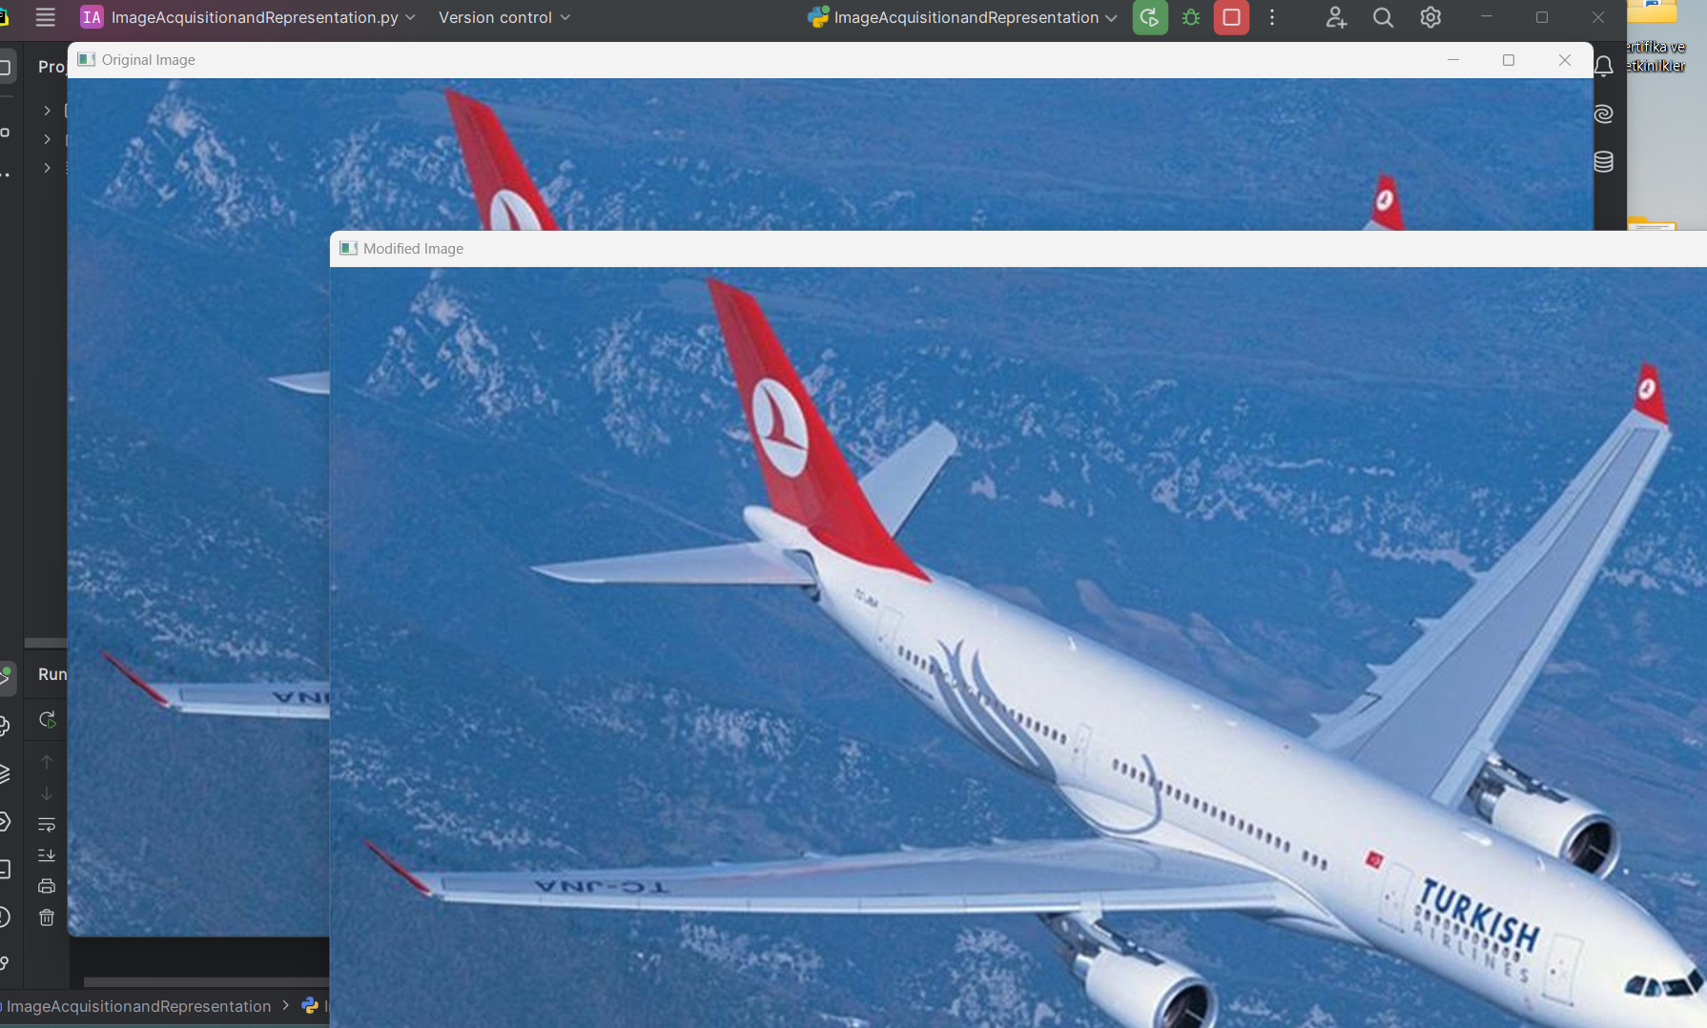

Report:
- Objective: Modify a pixel in an image using OpenCV.
- Input: "ucak.jpg" (color image).
- Steps:
  - Read the image.
  - Print basic image information.
  - Modify the pixel at (50, 120) to green.
  - Display and save the modified image as "modified_ucak.jpg".
- Output:
  - Two windows: one showing the original and one showing the modified image.
  - A saved file: "modified_ucak.jpg".

